Project Management Journal 1
Shepherd University Course MBA 532
Student Name: Randolph Butler
Instructor: Dr. Randy Butler

Project Management Concept:
Scope Management Plan will include a specific Scope Statement that defines the project detailing the project's major deliverables, its key objectives, and the work needed to meet those objectives.

Benefits, Advantages, and Disadvantages:

Examples on how the PM Concept is used:
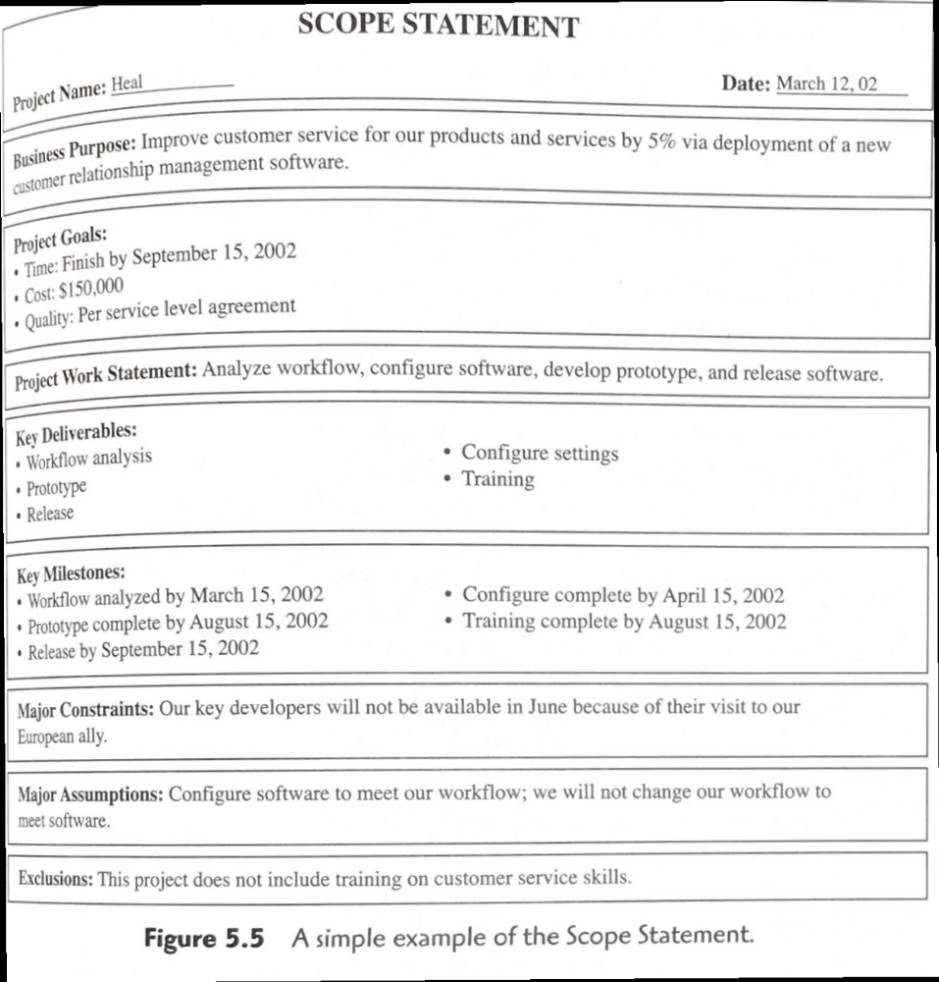

References:
A Guide to the Project Management Body of Knowledge (PMBOK Guide) – Project Management Institute, Inc., 2000, Figure 2-6, 19. Retrieved from: http://www.cs.bilkent.edu.tr/~cagatay/cs413/PMBOK.pdf
Butler, R.W. (2017, Apr. 9). Notes from Project Management Plan - AVL Project. Nebraska. Retrieved from www.vircolsol.com

